Providing the best available science
to coastal decision makers on California’s Central Coast

Santa Cruz Long-toed Salamander Workshop 2014
June 5, 2014
Elkhorn Slough National Estuarine Research Reserve
1700 Elkhorn Road, Watsonville, CA 95076
Contact: Virginia (831)274-8700

Sponsored by: Elkhorn Slough Coastal Training

Presenter: Wesley Savage Ph.D.

8:30 Registration, coffee and light snacks

Classroom session

Lunch

Classroom session

3:30pm Classroom session ends

Depart for Triple M Ranch

5:00pm Field session
Triple M Ranch (try to arrive a little early so we can get going right away)

8:00pm Field session ends

**please read the following pages for more information about the field session**

Afternoon field session information
Field work will focus on upland and aquatic habitat assessment and survey techniques at a location known to support the species. The instructor will discuss and/or demonstrate movement patterns, identification protocol, habitat management techniques, and habitat remediation. Participants will need personal vehicles to travel to field site.
Participants may not be afforded opportunities to capture or handle the species due to the unavailability of ponds with suitable water levels to support the species this year.
Please visit our website now to learn more:
http://www.elkhornsloughctp.org/training/show_train_detail.php?TRAIN_ID=Sa81GJB

Field site: Triple M Ranch

Address:
420 Hall Road
Royal Oaks, CA. 95076
Driving from the Elkhorn Slough National Estuarine Research Reserve:
Take Elkhorn Road east (left out of Reserve gate.) At the stop sign just past the fire station turn right onto Hall Road.
Continue on Hall Road past Las Lomas Market. The turn off is to your right across from Sill Road and Hall Elementary School. Look for a large sign on the right side of the road that says Horses for Sale and a small sign that says Triple M Ranch.

Turn right on to the dirt road, pass over a newly installed box culvert bridge and follow the road to the top and veer left following the Triple M sign.

Continue on the dirt road until you see a large gate in front of you and the road turns to the right; take that right turn and immediately park along the fence on the left hand side, you will see lots of sheep! We will provide maps at the workshop. Virginia’s cell 831-234-7011.

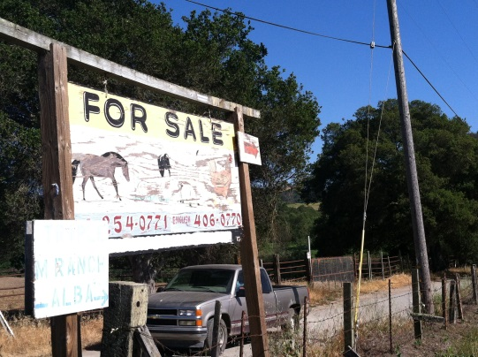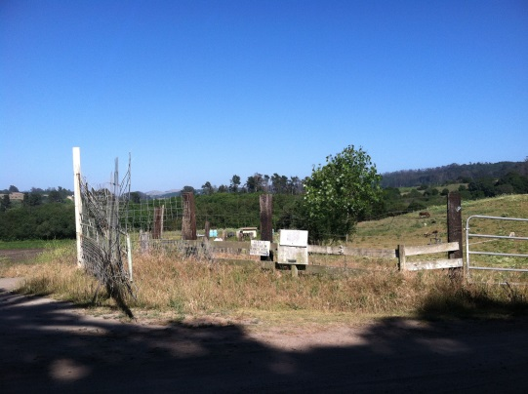
Entrance Large Gate with sheep
PLEASE READ THIS
IMPORTANT INFORMATION

It is very important that you arrive on time to the field site! Please leave enough time for traffic, for getting lost, and so forth. We will begin promptly and depart very shortly thereafter to places where you cannot meet us. In an emergency only, call organizers Grey Hayes at (831) 728-8050 or Virginia Guhin (831) 234-7011.

Supplies and equipment
We suggest waders or waterproof boots for the field session. Boots will be adequate if participants do not wish to venture into the water, but waders would provide the ability to conduct a thorough field investigation and to more thoroughly benefit from the hands-on elements of the training. We suggest you bring your own dipnets for survey practice.

Carpooling
See the workshop web page to view a contact list of those registered for the workshop who may want to ride share to the event.

Restrooms
There are no restroom facilities at the field location.

Comfort and Safety
Please be prepared for our sometimes very chilly conditions. Participants have been ill prepared in the past for the cold, windy, foggy, and moist conditions that are typical here on the coast. There is a possibility that it will rain, and fog can sometimes precipitate as if it were rain. It may also be quite windy and/or hot.

The field locations contain bodies of water within which participants may be surveying. If you are concerned about your ability to swim, manage slippery aquatic conditions in field equipment, etc., please let the instructors or workshop organizers know.

We will not be providing food or beverage as part of the field training session. If you are concerned about these items, please be sure to bring them yourself.

The sites may also present the following hazards: ticks, leaches, fleas, mosquitoes, other biting insects, poison oak, and rattlesnakes, (bug spray is highly recommended). Difficult to penetrate shrub communities surround the sites; the field session includes opportunity to assess upland habitat and some participants may wish to explore this typically difficult territory. The sites have uneven ground and travel to and from the vehicles may include uneven surfaces and short, moderately difficult hikes.

Due to the lack of water in ponds during the breeding season it is highly unlikely that we will find larvae.

Places to stay when visiting the Elkhorn Slough

Marina

15 minutes South on the coast highway, Hwy. 1. This is a small, ex-military town that is transitioning into a college town. There are a handful of restaurants and access to miles of little-used beaches or inland hiking trails.

Holiday Inn Express Hotel and Suites Marina - State Beach Area
www.ihg.com
189 Seaside Ave, Marina · (831) 884-2500
Directions · Details ·

Comfort Inn
www.comfortinn.com
140 Reservation Rd, Marina · (831) 883-4000
Ramada
www.ramada.com
323 Reservation Rd, Marina · (831) 582-9100
Directions · Details ·

Watsonville
20 minutes to the Reserve. This largely agricultural or service-based community is home to a lively Latino community with a historic town square, authentic cuisine, and lots of shopping.
Days Inn Watsonville
www.daysinn.com
1620 W Beach St, Watsonville · (831) 740-4520
Directions · Details ·

Holiday Inn Express Hotel & Suites Watsonville
www.hiexpress.com
1855 Main St, Watsonville · (831) 728-3600
Directions · Details ·

Monterey

30 minutes from the Reserve, depending on traffic, etc. This historic town is a highly desired tourist destination including the spectacular Monterey Bay Aquarium and the awesome Pt. Lobos State Park, gateway to the breathtaking drive down the coast highway into Big Sur. There are ample opportunities to dine and partake in all manner of tourist affairs.

There are so many places to stay, if you want to stay there we recommend you do some web searching yourself on this city.

