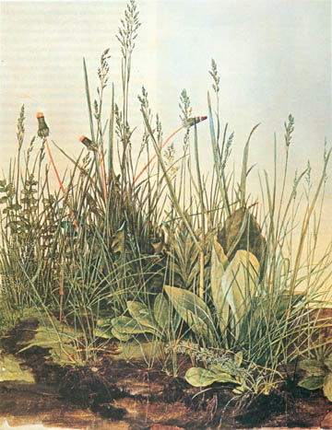
~ Central Coast Rangeland Coalition ~
Fall 2009 Membership Meeting

Rangeland Stewardship – Grassland Conservation

8:30-5:30
Thursday October 15, 2009

Coyote Grange Hall
8140 Monterey Rd, Coyote, CA‎ 95013
- Field discussion in the afternoon -

Meeting Goals
- Increase understanding of ways to increase the sustainability of rangeland management and grassland conservation

- Foster information exchange and collaboration

- Increase understanding and appreciation for rangeland management and grassland conservation

AGENDA

8:30 Meeting begins: welcoming exercise

----------------------------------------------

Panel discussion: conservation lands managers and ranchers discuss emerging issues, including:

- water quality policy and regulations
- species-level conservation
- monitoring
- advise for beginners

Panelists include: Cindy Roessler, Mid-Peninsula Open Space District
Pat Congdon, Santa Clara Open Space District; and ranchers - Steve Dorrance, Justin Fields, and Gordon Claussen

10:40 Break

11:00 Central Coast Rangeland Coalition Monitoring Program
2009 Monitoring Report: 60,000 acres, 18 properties, many partners
Overview, results, and analysis – Lawrence Ford and Devii Rao with time for audience feedback and questions

NOON Lunch – Bring your own!! Sharing encouraged

12:45 Emerging issues for rangeland stewardship & grassland conservation
A group exercise to report to funders, organizations, researchers….

1:30 – 2:00 Science and Monitoring on Serpentine Soil
A presentation on how scientists, conservation groups, and ranchers are working together to conserve an endangered ecosystem
Christal Niederer, Creekside Center for Earth Observation

5:30 Field discussions/presentations

Carpooling (10 minute drive) to the base of Coyote Ridge – discussions with Justin Fields and others illustrating management methodologies for conservation and management of sustainable rangelands. Moderated discussion will focus on convergent goals of ranchers and conservation lands managers, and how to make these relationships work better.

CENTRAL CALIFORNIA RANGELAND COALITION (“CCRC”) STATEMENT OF PURPOSE

THE CENTRAL CALIFORNIA RANGELAND COALITION (“CCRC”) BELIEVES THAT HEALTHY CENTRAL COAST RANGELANDS ARE INDISPENSABLE TO THE ENDURING HEALTH AND ECONOMIC PROSPERITY OF THE PEOPLE AND COMMUNITIES LIVING THERE. CCRC ENGAGES IN ECONOMIC, SCIENTIFIC, COMMUNICATION AND POLITICAL ACTIVITIES INTENDED TO DEVELOP AND MAINTAIN CENTRAL COAST CALIFORNIA RANGELAND POLICIES THAT ASSURE THE HEALTH OF CENTRAL COAST RANGELAND COMMUNITIES.

Many thanks to the event sponsors: Big Sur Land Trust, The Nature Conservancy, Santa Clara County Open Space Authority, and Elkhorn Slough Coastal Training Program.

For more information, and to reserve a spot, please contact:
Grey Hayes (831) 274-8700 or grey@elkhornslough.org

