Fire Safety and the Environment

Audience Needs Assessment

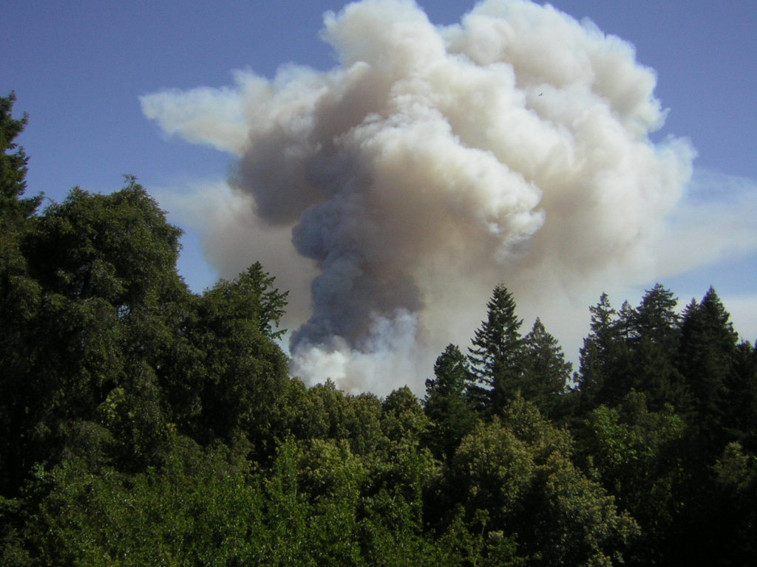

Elkhorn Slough Coastal Training Program
in collaboration with the
Central Coast Fire Learning Network

Grey Hayes, PhD

May 7, 2009

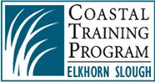
Martin Fire 2008 by Rachel Goodman
Introduction: Background and Purpose of Survey

The Elkhorn Slough Coastal Training Program (ESCTP) is exploring the assisting its partners with decision maker education on the subject of fire. When pursuing new areas of training, it is customary for us to initiate audience needs assessments to better design training events. In these surveys, we ask about specific needs for information as well as about when and where training events might take place. Increasingly, we also ask about beliefs and attitudes that can help facilitate a collaborative approach to learning between various interest groups.

And so, the ESCTP worked with some of those most actively supporting the formation of the Central Coast Fire Learning Network to design a suitable survey. The Central Coast Fire Learning Network (CCFLN) is a nascent group consisting of fire safety and resource conservation agencies, non profits, private citizens, and scientists interested in working together on issues of fire and human safety as well as the impacts of fire and fire safety measure impacts on biological conservation.

After review and comment by these individuals, we emailed an invitation to take the survey to 1800 individuals on February 26, 2009; this email invited those receiving it to forward it on to other interested parties.

The results of this survey can now serve as a road map to creating educational events that are well targeted to a broad array of decision makers who are crucial to issues of fire and human safety as well as the impacts of fire on biological conservation. The ESCTP looks forward to discussing these findings with the CCFLN Steering Committee to further refine near term goals and objectives.

Who responded?

We sent the survey to approximately 1800 people on the Coastal Training Program’s database of decision makers, urging those recipients to forward the survey to others. We received responses from many not on our original mailing list, thanks to those who forwarded the survey

In all, we received 234 responses from a number of audiences. Most responses were from researchers and scientists and homeowners as well as land and resources management staff (Table 1). There were relatively few regulatory agency staff respondents despite the database containing numerous contacts in that arena. There were 38 responses where people described themselves as ‘other;’ most of these were either interested individuals from various interest areas or agency personnel who felt that they were unrepresented in the available choices.

Lack of regulatory agency staff participation may have resulted for a number of reasons. First, this audience is often very busy. Also, the audience may not see a direct connection between their work and fire issues. Some follow up research could further clarify this issue.

Most responses came from the Monterey Bay area, but there were significant numbers of respondents from the San Francisco Bay areas, as well. The weighting of responses from the Monterey Bay area may reflect recent fires and elevated interest in that region as the mailing list included many from other regions.

Table 1: Numbers of survey respondents and the audiences they represent.

Concerns about Fire Safety

There were approximately 179 responses to our request to “Please list your most pressing concerns regarding fire safety.” We coded the answers into groups, but reviewing the individual answers is quite revealing; we can provide those interested with an internet link to review those detailed answers.

The biggest bins of responses included:

- 39 respondents (22%) who noted real fear for safety due to threats from fire; of these, many were concerned about proper planning in advance of fire but the most noted a need for better vegetation management in general.

- 27 (15%) of the respondents noted that their primary concern with fire safety was biological impacts of fire safety related activities. This despite our specifically avoiding asking about ecological concerns of fire suppression activities for this question

- 15 (8%) of the respondents were concerned with two other issues: 1) lack of proper education about fire safety and 2) proper planning for fire

Fire Safety Measure Impacts

There were 150 responses to the request “Please list your thoughts or concerns regarding the impacts of fire-safety measures on the natural landscape.” I again coded these answers into groups and, again, reviewing the detailed answers is quite enlightening.

- Most people (32, 22%) cited concerns with habitat degradation due to fire safety measures; many of these noted erosion and sensitive species concerns as well.

- 22 (15%) respondents noted concerns about invasive exotic species problems as exacerbated by fire safety measures.

- 17 (11%) expressed doubt that fire safety measures were effective.

Other major categories of answers included concern that natural fire regimes were disrupted, prescribed fire activities difficult, and that more education was needed for fire safety measures to be adequately implemented.

Priority Questions

We again coded responses into bins to summarize the data for people’s priority questions about fire. Table 2 summarizes the most popular requests for additional ifnormation.

Table 2: Areas of priority for additional education about fire.

Topic | Responses | Notes
BMP | 27 | What measures work best to protect lives and property prior to fire
Landscaping | 26 | What to plant and how to maintain planted areas for fire safety
CCFLN Goal | 23 | What is the Central Coast Fire Learning Network and what is the group’s goal
Prescribed fire | 23 | What are the pathways for improved prescribed fire
Risk assessment | 23 | How to assess fire risks for various situations
Collaboration | 21 | How to get people and agencies to work together for fire safety
Vegetation management | 21 | How to best manage vegetation to reduce fire danger
Balance | 19 | Finding a balance between fire safety measures and the health of species and habitats
Planning | 18 | Better ways to incorporate fire risk into municipal planning
Education | 18 | Communication and education tools for public awareness of fire

Assessment for Collaborative Potential

This section was designed to seek unifying beliefs for the various audiences that might be interested in joining the Central Coast Fire Learning Network. There was a surprising amount of accord on many fronts, and some interesting discord in others.
Areas of Agreement

Where we find agreement, the potential of the CCFLN becomes quite clear. The following are statements with which the audiences were in much agreement:

- “We can create landscapes that are more fire-safe while protecting/enhancing conservation values.”

- “Building stronger coalitions of conservation groups, land management agencies, regulatory agencies, and fire safety organizations is necessary to secure the funding and support needed to address the central coast's fire issues.”

- “Some natural systems/species depend on fire to rejuvenate.”

- Prescribed fire is a necessary component to effectively manage fuels and restore ecosystems in our region.”

- “The risk of damaging wildfire is increasing.”

- “There is insufficient funding for addressing fire issues.”

There are clear perceptions of increasing risk of fire as well as a need to use fire to maintain both safety and biological diversity. There is also a sense that there is something humans can do to make a difference, that people should work together to address pressing issues, and that additional funding is needed. Table 2 shows the level of agreement typical to the aforementioned statements.

Table 2: Responses to the statement “Building stronger coalitions of conservation groups, land management agencies, regulatory agencies, and fire safety organizations is necessary to secure the funding and support needed to address the central coast's fire issues

Answer Options | Fire safety agency staff | Resources management agency staff | Non profit conservation group representative | Private landowner | Public land management agency staff
Disagree | 0 | 0 | 0 | 0 | 0
Somewhat disagree | 0 | 0 | 0 | 0 | 0
Neither agree nor disagree | 2 | 0 | 0 | 0 | 0
Somewhat agree | 0 | 6 | 7 | 9 | 8
Strongly agree | 5 | 21 | 19 | 29 | 23
I don't know | 0 | 0 | 0 | 5 | 1
Problems to be Addressed

Leadership

The respondents spoke with less unanimity about the existing organizations addressing fire safety issues: Fire Safe Councils and CalFire.

Responses were mixed to the statement “Fire Safe Councils are important organizations for gathering support and resources to protect lives and homes from wildfire.” It is probable that there is a large portion of the population that are not aware of the potential for Fire Safe Councils and their role in fire safety measures. This is of particular concern with the private landowner audience, which showed the strongest uncertainty with this statement. Private landowners are the primary target of fire safe councils.

Likewise, responses were also mixed to the statement “CalFire is the best lead agency to provide citizens with the tools, knowledge, and assistance to create a more fire-safe landscape at the regional level” (Table 3). We received more individual comments on this subject than any other. Individual comments included the need for funding for CalFire, people’s lack of awareness of the agency, varying leadership depending on which CalFire office is involved, and the need for local fire districts to play the lead in many cases.

Table 3: Responses to the statement “CalFire is the best lead agency to provide citizens with the tools, knowledge, and assistance to create a more fire-safe landscape at the regional level.”

Answer Options | Fire safety agency staff | Resources management agency staff | Non profit conservation group representative | Private landowner | Public land management agency staff
Disagree | 0 | 0 | 2 | 2 | 0
Somewhat disagree | 2 | 3 | 0 | 6 | 5
Neither agree nor disagree | 2 | 9 | 10 | 11 | 9
Somewhat agree | 1 | 7 | 3 | 6 | 7
Strongly agree | 2 | 1 | 2 | 5 | 3
I don't know | 0 | 7 | 9 | 13 | 8

Perhaps the CCFLN should consider work with agencies and individuals to assist with better understanding and identity of the leaders working with fire safety. This will be a theme we will work with the CCFLN to resolve.

Education Need
s
There was an interesting split in the responses to the statement “I am interested in learning more so that I can better assist with protecting/enhancing conservation values.”
Fire safety agency staff responded in an interesting mixed array, with some individuals expressing interest and others more ambivalent or disinterested (Table 4). Most other audiences were much more interested in learning. It may be that the fire agency personnel have been well trained and feel that conservation values are well addressed. Or, the question could be so broad as to not elicit interest.

Table 4: Responses to the statement ““I am interested in learning more so that I can better assist with protecting/enhancing conservation values.”

Answer Options | Fire safety agency staff | Resources management agency staff | Non profit conservation group representative | Private landowner | Public land management agency staff
Disagree | 0 | 0 | 0 | 0 | 0
Somewhat disagree | 1 | 0 | 0 | 0 | 0
Neither agree nor disagree | 2 | 2 | 1 | 2 | 1
Somewhat agree | 1 | 1 | 6 | 7 | 2
Strongly agree | 3 | 24 | 19 | 32 | 29
I don't know | 0 | 0 | 0 | 1 | 0

Likewise, there were mixed responses to the statement,“we need better science before we can effectively manage fuels at the wildland-urban interface on the landscape-level”

The remarkable spread in responses (Table 5) suggest that many people are not sure about the need for additional science. However, there were a surprising number of individual comments specifically addressing this statement; a few individuals were clearly frustrated with others who wanted more information before addressing what they perceived as pressing fire dangers.
Table 5: Responses to the statement “We need better science before we can effectively manage fuels at the wildland-urban interface on the landscape-level”

Answer Options | Fire safety agency staff | Resources management agency staff | Non profit conservation group representative | Private landowner | Public land management agency staff
Disagree | 1 | 2 | 1 | 4 | 2
Somewhat disagree | 2 | 4 | 2 | 5 | 6
Neither agree nor disagree | 1 | 2 | 3 | 7 | 5
Somewhat agree | 1 | 10 | 9 | 16 | 9
Strongly agree | 1 | 6 | 10 | 8 | 7
I don't know | 1 | 3 | 1 | 3 | 3

Priority Training Subjects

Weighting the responses to lump the ‘very important’ and ‘major priority’ responses indicated the most popular training subjects. Current priorities across the audiences were, in order of preference:

- terrestrial impacts from varying fire frequency;
- plant species adaptation to fire;
- prescribed fire and land management, and;
- historic fire return intervals on the central coast.

While most audiences were very disinterested in hearing from insurance agencies on fire preparation and costs/risk assessment, fire agency personnel indicated that this was a very useful subject. In fact, this is the only area that this audience indicated as a priority subject.

There was less enthusiasm from all audiences about fire fighting budgeting, aquatic impacts from fire, fire fighting techniques, fire behavior modeling, community wildfire prevention planning, or land management concerns at the wildland urban interface.

Timing and Format of Events

The survey asked about many aspects of training formats. Shorter meetings were more popular, from 2 hours to half days. Weekday mornings were the best timing for such meetings. Day long meetings seemed possible for many respondents. Field components were rated highly.

The least popular meeting times were weekends and evenings.
Geographic area of respondents

We asked where respondents were most likely to attend educational events. Most indicated that the Santa Cruz City area was the most convenient, though many felt any location in the Monterey Bay area would suffice. A large number of people responded that they preferred the San Francisco area instead.

The Santa Cruz area was a popular option for location, but most anywhere in the Monterey Bay area worked for most respondents. A significant respondent group was, however, from the San Francisco Bay area and would prefer meetings in that region.

Conclusion

The survey results give the Elkhorn Slough Coastal Training Program and the Central Coast Fire Learning Network some valuable information for near term actions.

We now understand some of the priority training subject, how we might foster a collaborative approach, and where, for how long, and when it is most convenient for people to attend events.

For years, the ESCTP has been building its network of experts to help our audiences answer their questions. Now, we will turn to these experts and begin designing specific programs. And, we will work with our partners to see if additional resources can be brought to bear on this subject; we strongly believe that the best things happen when people are having fun- including good locally grown organic, in season foods in beautiful surroundings.

Stay tuned for some exciting events!

If you have additional insights or information, please let us know.

A full copy of the survey is attached as Appendix 1.

Appendix 1: Survey Form

